FOUNDATION FOR VIRTUAL AND AUGMENTED REALITY SYSTEMS
Lecture41
Lec-41: System Design
Hello and welcome to the NPTEL MOOCs course on Foundations of Virtual and Augmented Reality Systems. We are currently discussing the design of immersive experiences, and we are going to continue with that discussion in this part of the lecture as well. This is going to be the last part of this overall topic on the design of immersive experiences. Now, if we recap quickly, so far we talked about the basic idea of design, design of interactive systems, then talked about design guidelines; some generic guidelines we have covered which can be
considered as a starting point for any designer when he or she starts designing an experience. Also, we learned about different interaction techniques that are typically used in immersive settings, namely object interaction comprising object selection and object manipulation, navigation interaction comprising travel or locomotion and wayfinding, and interactions for system control. Now, in this lecture, what we will try to do is basically try to relate whatever we have discussed or learned so far, that knowledge to practice; that is, we will try to relate that knowledge to our design of the Majuli virtual reality tour.
So, this is our case study that we have introduced earlier. Earlier, we talked about general design ideas and various interaction techniques used in VR. And we utilize these techniques, this knowledge, these ideas to develop, to design the Majuli VR Tour. Let us see how we have related that knowledge to the tour design. If we can quickly recollect, the overall objectives of the Majuli VR tour were first to capture tangible and intangible heritage aspects of the island.
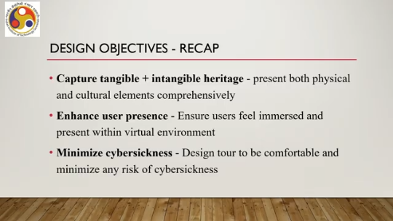
So present both physical and cultural elements comprehensively. Cultural essentially is intangible and physical elements are tangible. That is objective number one. Objective number two is to enhance the user's presence. That is to ensure that the users feel immersed and present within the virtual environment.
And third is to minimize cyber sickness because the spread of the island's geographic spread is large. And exploring the large geographic spread requires time and it is content rich. So that is likely to lead to cyber sickness if not designed carefully. So essentially the third objective was to design the tour. to be comfortable and to minimize any risk of cyber sickness.
These were the broader objectives when we started our design of the tour. So, the design considerations that were taken into account were user experience design, exploration of the island, and handling cyber sickness corresponding to the broader objectives. So in order to come up with the final design, we followed the iterative development approach that is the interactive system development lifecycle model. We followed where we followed the ISDL interactive system development lifecycle model by continuously refining our design ideas based on feedback and observations by involving the end users in passive or active ways.
So we followed the design prototype evaluate cycle. So essentially we came up with a design based on design guidelines. Then initial prototypes were made which were influenced by insights gathered from observing behaviors and preferences of the island's visitors who were the potential users. Now these observations helped decide the design choices of locations to cover user group categorization, how to identify the different groups of users, and integration of cultural videos and navigation features which are suitable for those groups of users.
Such user feedback or user involvement led to improvements including design elements such as minimap, notification system, and user controls. These are the elements that we incorporated based on user feedback and interaction with the users. So let us first talk about the user experience design. We have identified the first stage in experience design is to identify the user. Who are the users?
Accordingly, we can design the experience. So we have identified three distinct user categories, namely pilgrims, students and tourists. As you can see each group when I say distinct categories means each group has its own preferences for visiting the island or exploring the island. So the content and features of the virtual tour that we have designed were tailored to cater to the specific preferences of the user types and these preferences we collected through
contextual inquiry methods. Now based on that interaction and field trips and interaction with the users, user feedback and other things, we have identified and also with the need to cover the entire island, we have identified these information points on the island. These we have already introduced earlier. which included 9 satras, prominent satras, then 6 villages and the rest are towns and other places of importance on that island.
9 of such places, so 9 towns and other places. 6 villages and 9 satras. So these are the points of interest as marked here on this map you can see. We decided that by capturing the heritage aspects tangible, intangible both of these 24 information points we could be able to comprehensively capture the tangible and intangible heritage aspects of the entire island.
So, our objective was to essentially build or design a virtual tour that will cover all these 24 points on the island. So, we started with the design of the starting point of the tour, virtual tour. So, we added one introductory video about the island and also a tutorial video on how to use the system to acquaint the users with that tool. So, for that we have used these design elements such as one curved screen which shows essentially in an immersive setting it the screen is curved and it shows the introductory video about Majuli as well as the tutorial video can be played here to see,
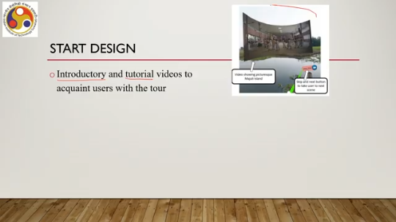
different aspects of the system how to use different aspects of the system then what we did is to give a natural feeling to the user we added one boat ride experience at the very start that means the user will be given the feeling of getting transported from one bank of the river to the other bank of the river that is from either from the mainland to the island or from the island to the mainland. So, in the starting part, we get the feeling of being transported by a boat from the mainland bank of the river to the island side of the same river. Now, this we have done by using a 360-degree boat ride video.
So, the user gets the feeling of actually traveling through a boat from the mainland to the island. And also we allowed the user to choose their user group before the actual experience begins. So, these types of icons were used to indicate different categories of users: pilgrims, students, or tourists. Now that is about the start design.
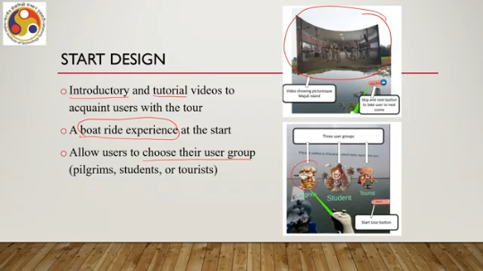
Then we performed some processing of the content that is the images and videos that we have collected to improve the visual appearance so that the user gets a better experience. So first thing is we used high-resolution images and videos, edited to remove unwanted elements. They came with some unwanted elements such as the tripod of a 360-degree camera which was used to capture the image. The tripod image or its shadow came into the image. So, we needed to remove that to improve the quality of experience that we did through the pre-processing.
And also, we edited the images and videos, mostly the images, to ensure uniform illumination. So, the images were taken at different points in time. Accordingly, the illumination effects were different. However, when we are using the images to create a scene, ideally what we expect is that the same illumination effect is there because the user is exploring the scene at a given instance in time. So, when the user is traveling from one image to another, this primarily refers to 360-degree images which we have used to create the scenes.
So, when the user is traveling from one image to another, if the illumination changes, then the user will get a feeling that there is something odd. To avoid that, all were uniformly illuminated using some image editing tools. We also have added ambient sounds. To give you a better experience, that means we have added natural sounds such as temple bells, birds chirping, and bike horns. These sounds were integrated to enhance realism and create an authentic ambience when the user is visiting a place.
So, depending on the place, a particular sound was added and played, such as temple bells were played when... the user is visiting a satra or a religious site. For interaction and navigation, we have done several things. First of all, there is one interactive tablet interface provided to the users in this way. Now, the tablet comes with several components,
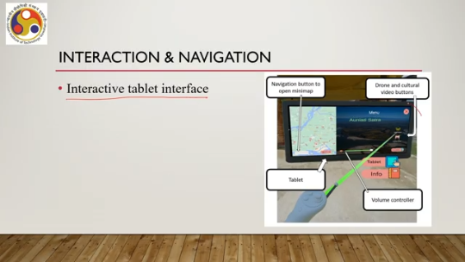
On the left side there is this whole island visualized. This is the world in miniature type of support we can say, as we have just learned in the interaction techniques. So we are providing a world in miniature in the form of a map of the island. There are buttons to open the mini map, but what is a mini map we are going to talk about in the next part of the lecture then. There are other facilities provided to visualize and experience that cultural video or that top view of a place through drone videos. So, a video player is also added which has volume controller and other types of controls, plus there are other
Elements added such as a tablet element. If we click on it, the tablet interface opens, or there are info elements and so on. So, the virtual tablet acts as the main interface and it provides the navigation tools, a video player, and access to information content. The design was inspired by the real world interactions to ensure familiarity and ease of use. So in real world also, occasionally nowadays, most of us use tablets to explore a place. So similar types of ideas were implemented here to give familiarity with our real world experience.
If you can recollect, this type of familiarity is important as part of design, as part of design as illustrated in the design guidelines that we have talked about. So, we have tried to apply the design guidelines as much as possible. Now, earlier we talked about the minimap. Now, the minimap concept is useful to provide a sense of belonging or sense of orientation to a place.
As I said, there are 24 information points on the island. Now, some of these points are quite vast in themselves. So, it is not just a single place. It is, say for example, one village or one town. That itself is a big place.
One thing is to provide a world-in-miniature type of map for the entire island. Another thing is, once the user is in a village or a town, that map is of no use, so we need to provide something different, which will give the user a feeling of where exactly on the island, at that place, the user is. So that is provided by the minimap. This is again another world-in-miniature type of support, but for a specific place on the island.
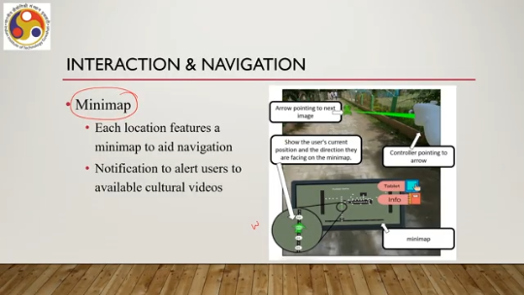
And its appearance is different from the earlier map-like appearance. Here what happens is that each of these places, say a village, town, satra, these are modeled using the 360-degree images that we have captured. Each place may have used more than five or six such images. Some places may have used 50 such images.
Some places may have used 10 such images. And essentially, when a user is navigating in a place, that means moving from one image to another, and these images are arranged in a specific form to provide the sense of direction and orientation. And this arrangement is reflected in this mini map. So, for example, here if you see the white dots essentially indicate the arrangement of 360 degrees.
Each dot represents a 360-degree image and for the user to explore it, the user can move along the dots in this direction, this direction, or this direction, or wherever the dots are. And whenever the user is at a specific point, that is at a specific image, that image is highlighted with green color so that the user notes that in this place I am at this specific location. And at each place there can be, so each location of these 24 locations features a minimap to aid navigation. And notifications to alert users to available cultural videos are also added to each place. So, what happens is that there is this arrow.
If I select the arrow, then I move in this direction. So, essentially I am moving along the arrangement of 360-degree images which is aided by the addition of this arrow. So, the user gets to see the arrow and selects the arrow to move in a particular direction. The green spot shows the user's current position.
This is the overall minimap and then we have a tablet interface. So at any point in time, I can open the tablet which I have just discussed in the previous slide and also the information icon. So if there is something to be seen at a specific spot, the information icon becomes active, and if we select it, then it shows whether there is any cultural video at that spot or not, then it can be played on the tablet icon. For location awareness, we have used dual maps: global and local,
that is, the global map on the tablet interface and the mini map on the local interface to reduce clutter and provide clear navigation support. And also, they help in wayfinding as they are showing the entire world in a miniature form. The same technique also helps in orientation awareness. The mini maps are there to provide dynamic orientation awareness to provide users with spatial orientation in which direction to move. And that, in a sense, helps users create a mental map and perform wayfinding.
Next is exploration. How to explore the island? What are the things that we designed to let the user explore the island in a good way? So one is smooth transition. I just mentioned that each place is designed using a series of 360-degree images.
So when the user moves from one point to another, that is essentially moving from one image to another. Now if the image transition is not properly taken care of, then what happens is that the user gets the feeling of sudden movement, jerks, which, of course, obviously reduces the user experience. So what we have done is that we have used a view interpolation technique which ensures smooth visual transition. So view interpolation essentially blurs the boundaries between two images so that user gets a smooth feeling of transitioning from one image to another.
Along with that, as I have shown in the previous image, There are arrows to guide users, creating a seamless exploration experience. So, the arrows essentially let the user move from one image to another; the user cannot randomly move around. So, the arrows are provided to guide the user for a smooth travel experience. So, these two techniques, arrows and view interpolation, were used for smooth transitions from one image to another while exploring a space.
We have also added a virtual vehicle metaphor. Essentially, it is a 3D model of a vehicle that facilitates long distance travel within the tour. So, one of the objectives of the tour is to let the user explore the island as well, not only a single space. Now, a single spot of these 24 spots, exploration of that spot involves walking-based navigation. However, to explore the entire island, walking-based navigation is going to take a lot of time.
So, and which essentially may lead to cyber sickness. So some different travel technique was required that we did using this virtual vehicle metaphor, which is a 3D model of a vehicle. And using that vehicle, we actually implemented one travel technique where the user gets the feeling of traveling using that, through that, or riding that vehicle. This is the vehicle metaphor used. And once the user selects it,
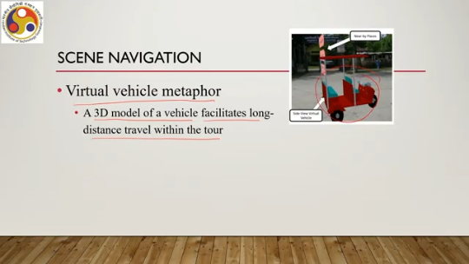
The user gets a viewpoint of sitting inside the vehicle and then the vehicle starts moving. Then the surrounding scenes of the vehicle get changed so that the user gets the feeling that the vehicle is moving. Now users can operate the vehicle through ray casting interactions. It can provide the direction of movement. And the user can select the place to move and accordingly the vehicle moves to that place.
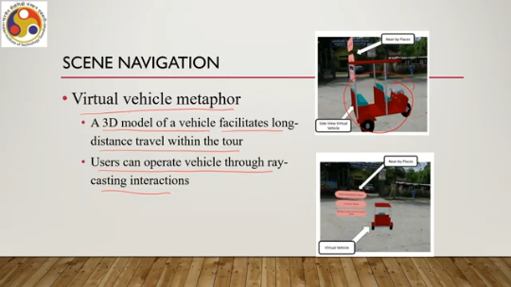
So essentially this technique refers to a selection-based locomotion technique where we have used a kind of route planning, but the route is pre-planned and the user selects a destination to actually select a route. It is not target selection or instantaneous movement. It is route selection essentially. Now there are lots of video and textual information as part of the content that we have designed, we have collected and integrated into the system, into the tour.
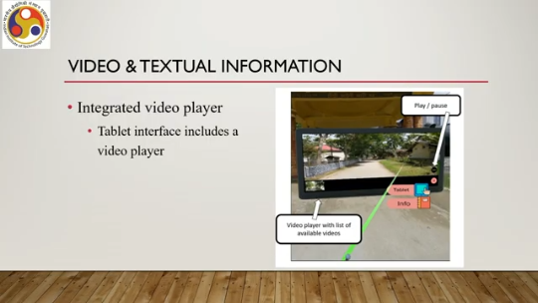
Now to let the user explore such video and textual information, first of all for video information exploration, we have integrated a video player, I already talked about it earlier on that tablet interface. So the tablet interface includes the player and it allows users to access cultural and ecological videos relevant to the current user location in the virtual world as shown here. You can see here that the video gets played. This video can be a 360-degree video, a drone video, or a 2D regular video.
And also it shows a list of available videos for a given spot. So whenever we are at a spot, the corresponding material available at that spot gets added to this tablet interface and then the user can choose. In that way, we ensure that the user gets access to the most relevant information at a given spot. And this information is also determined based on the user type.
Also, we have some textual descriptions of a place. For that, informative notifications and descriptions appear. It provides additional context about locations and significant spots, enriching the user's understanding and engagement. For point of interest awareness, to make the user aware of points of interest, we have added directional arrows, as already mentioned, which way to move, and information icons, such as these. The arrows guide users to the points of interest.
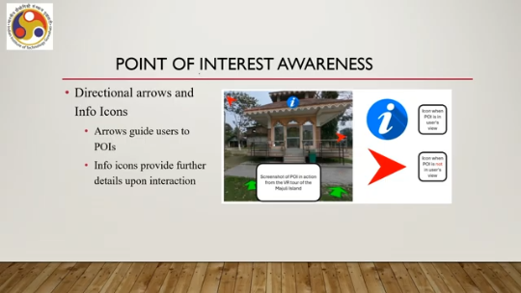
So, in that way the system is designed and information icons provide further details upon interaction. So, if we select it then it shows us details about that place mostly in the form of textual information. These additions were made to ensure that users do not overlook important elements within the environment. The third major objective was cyber-sickness minimization. How did we do that?
How do we handle cyber-sickness? Let us quickly discuss. So, we have essentially implemented a controlled navigation technique. Users can navigate or teleport using a joystick and it reduces abrupt movements that can cause discomfort. So, we provided controlled movement.
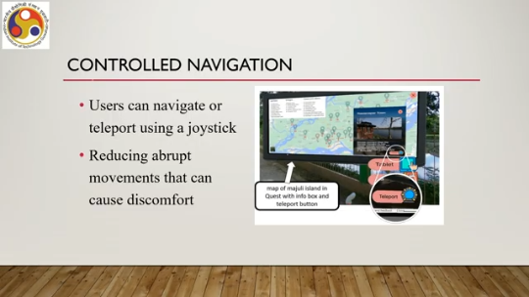
which reduces the chances of discomfort because it does not support abrupt movements. However, this vehicular movement, if we do not choose the speed carefully of the change of viewpoints, the speed of change of viewpoint, then that may cause a little bit of cyber sickness. Also, consistent visual cues and smooth transitions that we have implemented in the design. help maintain spatial orientation and reduce sensory conflicts. User gets a better feeling of the place and better awareness of the place which reduces anxiety and also it reduces sensory conflicts which
In the long term, it helps the user avoid having severe cyber sickness effects. In fact, as per our studies, which we will be discussing in the next lecture, we found that cyber sickness is minimized in our design. So with that, we have come to the conclusion of this part of the lecture and the overall lecture. Just to summarize quickly, we have discussed in this lecture; our focus was the design of immersive experience.
So we have discussed the idea of design. Here the term design refers to interface and interaction design, not the code design. We talked about design guidelines, which is the starting point. So, we mostly focused on generic design guidelines.
We also talked about interaction techniques typically employed in immersive experiences. And finally, we talked about how those ideas are used to design the VR tour. If you recollect, so we have utilized navigation techniques. We have also utilized manipulation techniques, selection, object selection, object manipulation and navigation including travel and wayfinding techniques in our design.
And we followed an iterative design, interactive system development lifecycle to come up with the design of the tour. So, in the next lecture, we are going to talk about the implementation of extended reality systems and how to evaluate such systems both from the point of view of a system as well as from the point of view of usability or users. Our focus primarily will be usability evaluation whether we meet the design goals and at that time, we will also talk about how we implemented the module system and how we evaluated it, and what are the evaluation results.
So the lecture materials are primarily taken from these sources. If you are interested, you can go through each of these references. You will get more details on the ideas that are covered in this lecture. So there are four references provided. It will be beneficial if you go through them to get more details on the topics covered.
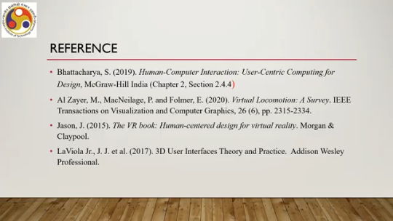
So with that, I would like to conclude this lecture here. Looking forward to meeting you all in the next lecture. So, thank you, goodbye and happy learning.

